The Concept of Story
Hot
JJackwraithUpdated May 21, 2021
4053 0
Add to favorites
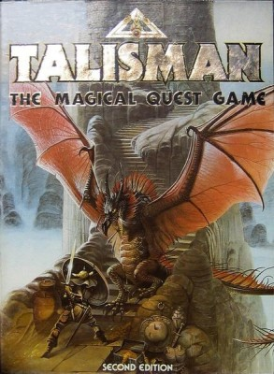
Do your favorite games produce a story and does it matter?
What's often lauded as "The Difference" between what are nominally called Eurogames (think Reiner Knizia) and Ameritrash (think Talisman) is the concept of story. The latter tend to tell them, while the former tend not to. What I mean by "story" is that recounting a game to someone else, whether present or not, is often like telling a story. I usually cite Talisman as an example because it's clearly set up to function in that fashion and because I once used a great story of one of my games to convince a friend who was then an RPG-only player to give it a try. He specifically marveled at the fact that "a board game could tell stories like this!", as if it were some incredible possibility. And, to someone raised on games like Sorry! and the oft-maligned Monopoly, it probably was an instance where the idea of getting something more out of a play- and, in fact, something quite close to an RPG experience -just wasn't something he'd ever considered. The story I told him was that I'd gone into a Talisman game with a regular opponent who was determined to beat me (I was mildly infamous in our group for being the regular winner at that particular game.) He had a plan all set up. He started as the Troll, built up his Strength, found the Ancient Artifact, turned it in at the City to become the Archmage, built up his Craft, and then started smashing his way around the board. By that time, two other players had died and given up, while I had died as the Sprite and was on my second hero, the Leprechaun. As he moved to the Portal of Power, I delayed him for a couple turns by casting Hex on it and then asked him why he didn't just come hunt me down and win, especially because I'd done just that in our previous game, by slaughtering everyone with a Runesword-equipped Rogue. He said: "No! I'm going to win the right way!" So, I shrugged and continued to mill around, doing minor things to progress while he ran riot through the top level, and finally picked up the ending card. He then promptly stormed out of the room after falling into the Horrible Black Void, leaving me as the only player left on the board...
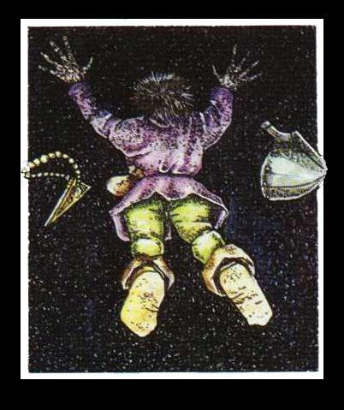
You're probably not going to get a story like that out of a play of Through the Desert because TtD just isn't that type of game. Talisman is set up to tell stories like that through rolls of dice, card draws (Drew a Dragon as your first encounter and lost a Life point? Sorry 'bout yer luck!), and other random events that a lot of people don't like. Through the Desert functions with almost perfect information. You're going to win or not win based on your own efforts and the actions of the opposition, not because someone drew the worst possible ending for a game and lost just by a turning over a card when they were clearly the superior character. But moments like that in Talisman are the stories that will last for years (said game happened 28 years ago), whereas I can't tell you what precisely happened in my last game of Through the Desert that took place two months ago (I know I won, but that's about it.) I'll likely never forget that game of Talisman because that's what the game is designed to do. That doesn't mean the game itself is better. Indeed, I don't think there's any comparison, mechanically, between a game like Talisman and a game like TtD. The latter is clearly the better game mechanically, but the two games are set up to provide a different experience. It's like the difference between subtle humor and shock humor. One is enjoyable because it's usually a good insight into a situation. The other is enjoyable because it's a surprise that often flusters or unnerves you. Most have a preference for one or the other, but still enjoy the alternative to a degree. And this also isn't a declarative that non-Ameritrash games can't tell stories.
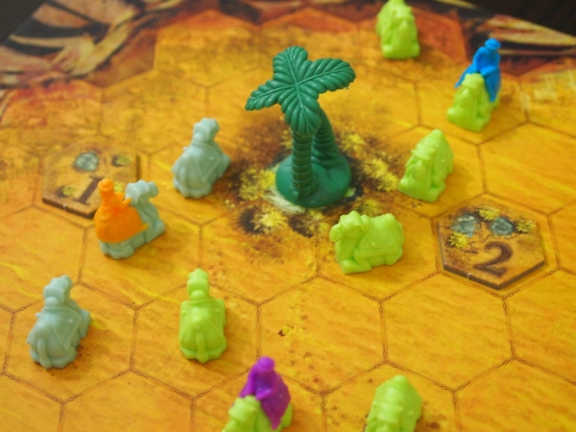
Think of abstracts like chess or poker. There are lengthy stories that can be told about good chess matches, like in The Queen's Gambit. Similarly, legendary poker games can be the foundation of films like Rounders. Both of those examples work because of the high tension involved in their situations and because those games are often as much about playing the opponent as they are the game itself. This is the root of the Euro fan argument about "skill" being more important in games like Taj Mahal. If you're all playing with the same pieces, then the way you use those pieces is supposed to demonstrate your playing ability in comparison to those playing with you. But that, of course, isn't wholly accurate. Taj Mahal still involves a random card draw and games like Tigris and Euphrates also involve a random draw, just like Talisman. Furthermore, the way you deal with random events or hedge your bets in taking risks in Talisman is every bit the gaming skill that picking the right spot for a palace in Taj is or in knowing how to play your bet in a poker hand. Those, too, are moments of story. They're just less obvious than squaring off with the Demon Lord at the top of the Talisman mountain.
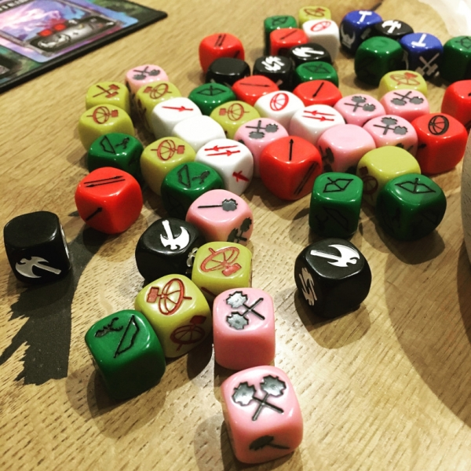
Modern design has followed that path, with more mechanically-sound games that can still evoke those "Remember when...?" moments on a regular basis. Take Champions of Midgard as an example. It's one of the most worker-placementy of worker placement games, but it's also about Vikings fighting mythological creatures. It also involves dice(!), the longstanding black spot of supposed Eurogamers because of their inherently random nature. But, again, just as with Games Workshop games, rolling a fistful of dice means planning beforehand such that even a poor roll will often gain you the result that you wanted, anyway. That, too, is a gaming skill. Also, dice inherently create those moments of story because of the tension and uncertainty that they generate. But even games with almost-perfect information can still create those moments. Our most recent game of Pax Pamir, 2nd Ed. was a good example. Late in the game, a Dominance Check card had emerged in the market, which would've been an ideal get for two players supporting the Russians, as the yellow pieces were everywhere on the board. But a player supporting the British decided to play Prince Akbar Khan, switching his allegiance to the Afghans and changing the favored suit to Military, which doubled the price of that Dominance card, putting it beyond the reach of the Russian players. It was also a huge risk to his own position, since it wiped a couple British cards from his court and put a Persian tribe in a precarious spot. But with the Prince, he later used its two spies and double combat ability to sabotage his opponents and pick up the Dominance card himself for a win with the Afghans. There was no randomness involved. Just smart play.
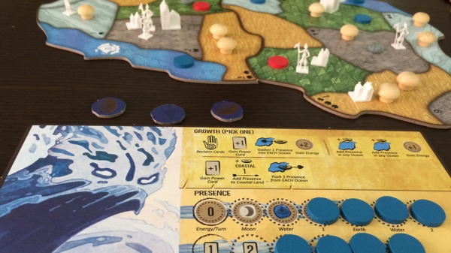
But even beyond player-created moments, let's think about modern "Euro" games that generate story just based on their setting and characters (like Talisman.) A great example is Spirit Island. Mechanically, it's difficult to consider Spirit Island anything but a "Euro". It's a process game. It has multiple intricate systems that have little to do with randomness (outside of the Event deck and what Minor and Major powers show up in their respective decks.) But it's hard to imagine a game where players are Shadows Flicker Like Flame, Lure of the Deep Wilderness, and Ocean's Hungry Grasp competing with the Hapsburg Monarchy and using powers like Rain of Blood and Gift of Living Energy as anything but a story waiting to be told. Who's going to forget that time when the English had almost overrun the island with cities and Blight before Finder of Paths Unseen used Vengeance of the Dead to claw out a Fear victory at the last minute? Obviously, there's a lot more storytelling texture in a game like Spirit Island than there is in a game like T&E, but in the latter you will always find the back-and-forth struggle over cities and a moment where a properly played Catastrophe that might've prevented the addition of one more point in someone's smallest VP total... Yeah. There are stories there. (It also kind of belies the "pasted on theme" label that tends to follow Knizia around.)
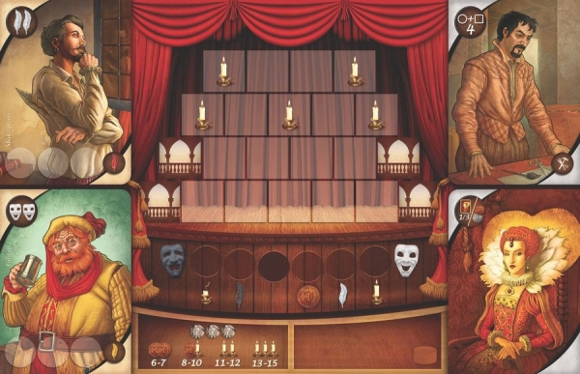
An interesting contrast is a game like Shakespeare. The game, of course, is based on the Bard of Avon, one of the foundation stones to storytelling in the Western tradition. But it's also a fairly intricate engine builder that doesn't create obvious "Aha!" moments that might be considered something to retell at a later date. A lot of the people you employ/activate for your tableau aren't anyone notable other than Set Designer, so you aren't fully in a stylized role as in Spirit Island, although you do have access to many of Bill's famous characters who do different things somewhat based on their roles in the plays. Furthermore, it's a very technical situation, in which you're trying to balance prestige points (VP), money, and action efficiency. All of that can be a story-generating device, but is often more like figuring out a puzzle in the midst of a group of people (aka multiplayer solitaire), which doesn't often lend itself to those memorable moments. Unless Romeo was devastating for you in any particular game, it won't be like referring back to that time you played Calavera, Eagle, and Wengsi Wong versus Gluttony in a game of The Others.
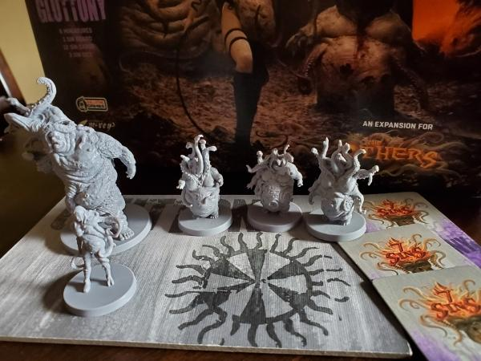
The irony of a game about Shakespeare tending to not produce a storytelling moment is pretty thick. But that game isn't really designed to be that kind of exercise, in the same way that games like Power Grid aren't. In truth, the real generator of stories is often the players themselves. Not every session of any game is going to generate a story. I have most of my plays of Talisman recorded (What characters were played, who won, etc.), but I can look at any number of them and not really recall any specific details about them. That doesn't mean they didn't generate a story. It just means that it wasn't a memorable one. The fact that you can go through a number of plays of Modern Art or Agricola without having their details surge forward in your head the next time you get people together to play doesn't mean that they didn't leave an impression on someone who was at the table. They might not occur to you because you didn't win. But someone did and someone probably remembers.

The Setup:
Saturday night, six people gathered to decide the fate of humanity over bottles of Miller High Life. The players (in play order):
-Admiral William Adama (myself)
-Lee Adama (Adam)
-Saul Tigh (Autumn)
-President Gaius Baltar (Matt)
-Kara “Starbuck” Thrace (Gina)
-Galen Tyrol (Winter)
(Note: I’ve described the players below according to the gender of their character rather than their actual gender. Tyrol and Tigh were played by lovely ladies, but are described below with masculine pronouns for thematic purposes. Hopefully they won’t hold this against me.)
I was hosting the game, and no one had ever played before; but I’ve been evangelizing for this game for weeks, so both spirits and expectations were high. I had all the components laid out, with examples of each type of Crisis card, each type of skill card, and each type of loyalty card. I pushed through the explanations pretty fast, assuring everyone that they would understand once we got underway.
“Basically,” I explained. “Battlestar Galactica is a game where terrible things are going to be happening to you constantly. If you work together, you may be able to make some of these things slightly less terrible, or occasionally avoid horrendous trauma altogether, or at least have a choice between two equally hideous fates. Excited?”
They were.
Now I’ve played this game four or five times, and I can only recall being human the whole way through once. I have uncanny Cylon karma, and as I dealt out the loyalty cards, I prayed to the gods of Kobol for a reprieve.
I turned over my loyalty card, and Boomer was pointing a gun at me.
“You are a Cylon,” she said.
Crud.
Now I have to explain to all these noobs how to win the game while I try to undermine and destroy them. Good thing I’m the Admiral.
Act I: A Rough Start or ”That’s only bad if we’re boarded by centurions.”
Honestly, I’ve never seen a game start out quite so dire. It seemed like everyone picked up the rules and mechanics really fast, but suddenly there were five raiders off one launch tube and two heavy raiders off the other one. Alert pilot Lee Adama became alert patient in the sickbay. A shot from a Basestar damaged our Armory. “That’s not so bad,” I explained. “Unless we’re boarded by centurions.”
We were boarded by centurions.
Finally, Starbuck forewent jumping in a viper for activating the FTL. We left the Cylon fleet and 1 population behind us, but we would have lost a lot more if those raiders had reached our civilian ships. I drew two destination cards and chose the “1” distance destination card that allowed us to repair some of our vipers. I explained to everyone that going only “1” distance was pretty poor, but that most of the destination cards had some kind of crappy consequence.
It came to Tyrol’s turn: a perfect opportunity to repair the Armory and take a shot at the centurions, but Tyrol mournfully explained that he had used his last repair card on a previous skill check, and so he headed to the research lab instead. Thus, the first sparks of suspicion were kindled; why wasn’t our engineer repairing things?
More turns followed, and the centurion moved steadily towards humanity’s doom. “I don’t have an executive order,” I explained through lying teeth, “but if someone did have an executive order, they could order Tyrol to move to the Armory and repair it.” Thus, I fulfilled my role as both teacher and traitor. Lee Adama didn’t have an executive order either, so it fell to Saul Tigh to order Tyrol to the Armory and repair the damage.
President Baltar tried to make an inspirational speech to rouse morale (which was already pretty low), but failed to energize his core demographic. Starbuck moved to the Armory and took a shot at the centurion, and missed. Then Tryol, in an odd twist, played an executive order on Starbuck. Two more shots, the second of which was aided by Saul Tigh’s strategic planning card, and the toaster was toast. Huzzah for barely surviving!
Act II: Growing Suspicions or "It's like there's a party in the brig, and everyone's invited."
The ship jumped again, and we moved a pitiful “2” distance. Before you accuse me of taking advantage of their naiveté, I made sure everyone understood that the cards ranged from 1 to 3, and that I was choosing low distance cards. Of course, I said I was doing it to protect our resources.
A season of relative peace passed by. The Cylon fleet didn’t show up, and the humans gathered their resources, but they were still losing skill checks, and the dials were dropping. A particular skill check resulted in three negative skill cards, and so the humans knew there was a Cylon out there. And since I hadn’t played any skill cards in that challenge, I knew I wasn’t alone.
Another skill check resulted in four negative skill cards: 2 piloting, 2 engineering. The two main culprits were Adama and Tyrol, since Starbuck hadn’t contributed. Both were suspicious, but the weight of accusations fell against Tyrol for the “I’m out of repair cards,” play earlier. Lee Adama moved to the Admiral’s quarters and had her thrown into the brig (I’ll admit, I helped a little bit. I didn’t think Tyrol was a Cylon).
We continued to fail skill checks, and the general sentiment was that Tyrol actually wasn’t a Cylon. They tried to bust him out of the brig, but a leadership card sabotaged the skill check (I wonder who played that?). Fortunately someone drew a crisis card that allowed a chosen player to be sent to Sickbay, and Tyrol was moved there, circumventing the horrendous “get-out-of-the-brig” ordeal for the horrendous “get-no-skill-cards-ordeal.”
I had the opportunity to reveal myself as a Cylon, but decided to hold off. We were close to jumping, and I felt like if I could choose another dinky destination, I could really sink this fleet.
Alas, it was not to be. Saul drew a Crisis card that allowed him to look at an opponent’s loyalty card, and he checked me out.
“He’s a frakkin’ skinjob!” Tigh shouted.
Now this isn’t my first time playing a Cylon. When you find yourself in a situation like this, you can’t get defensive or become angry. Take a breath.
“Oh my God.” I looked surprised, and then disbelieving. “You’re the Cylon.” And I said it with a straight face. And I felt everyone look from me to Saul to me to Saul, and they weren’t sure who to trust, and I saw that look in Saul’s eye, that hurt, betrayed, furious look that says, you just made me a SUSPECT.
That’s cool. I had the same look on my face. I cracked up once, but nobody saw it.
The turn passed to President Baltar, who used his once-per-game ability on me to look at my loyalty card. The room was tense as everyone awaited the outcome of his analysis. I looked hopeful, glad for the opportunity to be vindicated.
“He is a Cylon,” President Baltar announced.
“See?” Saul cried.
“Okay,” I said. “Now we know who the two Cylons are.”
I lined up the pieces. Those two negative engineering cards? President Baltar is an engineer. All those negative tactics and leadership cards? Saul Tigh gets leadership and tactics cards. What a well-played coup. And, I reminded them, if I lose the title of Admiral, it goes to Saul. Just before a jump, too.
Obviously, it was hard to swallow. But I didn’t need them to swallow it—just choke on it a little. And from the uncertain looks around the table, I’d managed to plant the seeds of doubt.
But the seeds of doubt can’t help much against Saul Tigh’s “Cylon Hatred” ability. President Baltar convinced Starbuck to use the “Admiral’s Quarters” against me. Although I had a bunch of skill cards from using my “Command Authority” once-per-game ability to take all the skill cards from a previous challenge, it couldn’t help against a mostly united effort to send me to the brig at a -3 difficulty.
Then, we jumped. The new Admiral Saul Tigh finally understood the burden of leadership when he looked at the destination cards.
“These are both terrible,” he groaned.
He played a “2” distance, and the sleeper phase triggered. Morale was in the red, so no danger of the sympathizer becoming a Cylon. But guess who’s the Cylon sympathizer? None other than Saul Tigh.
The Admiral-for-a-day joins me in the Brig, and Lee Adama becomes Admiral. Chip off the old block, that one.
As it was, Saul had joined me in the brig just in time to see me off myself. Goodbye, Galactica. Hello, resurrection ship.
Act III: The Gloves Come Off or A Chip Off the Old Chassis
The Cylon fleet finally showed up. Saul was freed from the Brig, but did not automatically regain the rank of Admiral—that still belonged to Lee. Starbuck took to a viper and wasted some raiders, but a lucky 8 on a raider’s roll sent her to the Sickbay (it was actually two eights in a row, since she played evasive maneuvers on the first one). Things were looking pretty bad when I played my Super Crisis Card, “Bomb On Colonial One.”
I imagine that, after the skill check was tallied, President Baltar, from his desk on Colonial One, tugged on his collar with one finger.
Boom.
Goodbye, executive branch. It was nice to know you.
Morale dropped down to “1.” The fleet was on the verge of crippling depression. They were wearing more black and writing bad poetry.
But then Admiral Lee Adama, his viper shining like a white horse, flew into battle against the Cylon raiders and blasted them to pieces—one, two, three. With a devilish grin and a cut jaw, his gave the fleet a thumbs up through the canopy of his space fighter, and all of humanity breathed a collective sigh of hope.
A crisis popped up. The Admiral would choose between two terrible fates, a loss of population or a loss of morale. A difficult choice, to sacrifice lives for hope, but the course of action was plain. After the disappointment of all their previous leaders—a traitorous Admiral, a drunken, Cylon-sympathizing XO, and an ineffectual, exploded President— could this handsome young viper pilot lead them to the promised land?
Through the cockpit canopy, across the gulf of space, the Admiral’s boyish eyes glittered as he mouthed his answer.
“Nope.”
Following the finest tradition of military leadership, Admiral Lee Adama sided with the Cylons and doomed humanity.
Upon his return to the resurrection ship, Lee and his father had a heartfelt reunion. Tears were shed, and embraces were held for slightly longer than was comfortable. Daddy-issues were resolved.
“I’m proud of you, son,” William Adama said.
“We did it, dad,” Lee said.
*cue sentimental music*
*fin*
Wrap-up:
Everyone really enjoyed the game, despite the whole “death-of-the-human-race” ending. Starbuck regretted not being able to get in a viper more often, but the Cylon fleet just wasn’t showing up much in this one. Apparently Lee Adama had been a Cylon from the start, and the father & son combo had just been too much. Saul Tigh, who is my roommate, may never forgive me.
The next day, when I opened the fridge, I realized that we had drunk all my Miller High Life. If that’s not the sign of a successful evening, then what the frak is?

Making compelling narratives in board games using the three-act structure


Morten Monrad Pedersen

@mortenmdk
Post DateSep 7, 2014 4:15 PM
- 44
- Give GeekGold9.4geekgold

I love story arcs and I love board games. The craft of storytelling is ancient and thus experience is plentiful on what makes stories work - some of it can even be condensed into simple structure rules. Board games that tell stories however are a recent phenomenon, and not nearly as mature, but if there’s one thing that fits well in board games, then it’s rules and structure, and so it seems natural to take a look at the rules of storytelling and see if they can be converted to board game rules.
We’ve already been down this road once before on this blog (The 3P-Principle - or what the craft of storytelling can teach us about solitaire game design) and today we’ll take further steps by looking at the classic three-act structure.
The three-act structure
The three-act structure is a simple way of structuring stories that over millennia has been shown to help create compelling stories. In this structure a story is split into… yes, you guessed it: Three acts . I’ll give a brief explanation of the structure and I’ll use the 2011 Conan the Barbarian movie as an example. This isn’t because it’s a good movie (it’s not), but because it follows the three-act structure, and because I don’t think it’ll ruin much for anyone if I spoil its overall plot .
Act I - The Setup: This is where the characters and world of the story are introduced, and the tone of the storytelling is set. Act I ends with Plot Point I – a pivotal event that changes the situation of the protagonist irrevocably, sets her on her path, and raises the Fundamental Question of the story, which will be answered during Act III.
In Conan the Barbarian, we start out seeing Conan being born during a battle and we follow his first years. This shows us the world and type of characters, and sets the tone of the story well.
The first act comes to an abrupt end, when the forces of the evil warlord Khalar Zym razes Conan’s village and leaves Conan with the choice of saving himself or trying to save his father. This is Plot Point I, which destroys Conan’s world, sets him on the path of vengeance that defines the rest of the movie, and raises the fundamental question of the story: Will Conan get his revenge on Khalar Zym?
Act II – Confrontation: This is the main part of the story in which the protagonist confronts a series of challenges. The stakes rise and often it turns out that she lacks what it takes to overcome the final challenge and thus Act II sees her acquiring these skills or allies who can help. This development of the protagonist is called the Character Arc.
Act II ends with Plot Point II, a dramatic event that thrusts the protagonist into the climax. It’s clear here that the stakes are very high.
In Act II of Conan the Barbarian we follow Conan around the world. He grows up, acquires better combat skills, hunts for Khalar Zym, and faces several challenges posed by the henchmen of Khalar Zym. Along the way Conan also picks up some allies.
Plot Point II happens as Conan’s ally Tamara is captured by Khalar Zym. Performing a ritual where Tamara’s soul is replaced by Khalar Zym’s dead wife is the last step in the process that will make him all-powerful and thus the stakes are as high as they can get. The scene is now set for the Climax.
Act III – Resolution: This is it. The Climax of the story. We get the answer to the Fundamental Question. Often we’ll also get a short ending where lose ends are tied up and we get a glimpse of what’ll happen to the protagonist and her allies afterwards.
Our old reliable friend Conan doesn’t let us down in following the structure. He faces off against Khalar Zym to save the world and the damsel in an epic showdown, and after the evil warlord is slain, we get a glimpse of Conan and Tamara parting ways. Both go to their own birthplace, and in Conan’s case we see him telling the memory of his father that his death has been avenged.
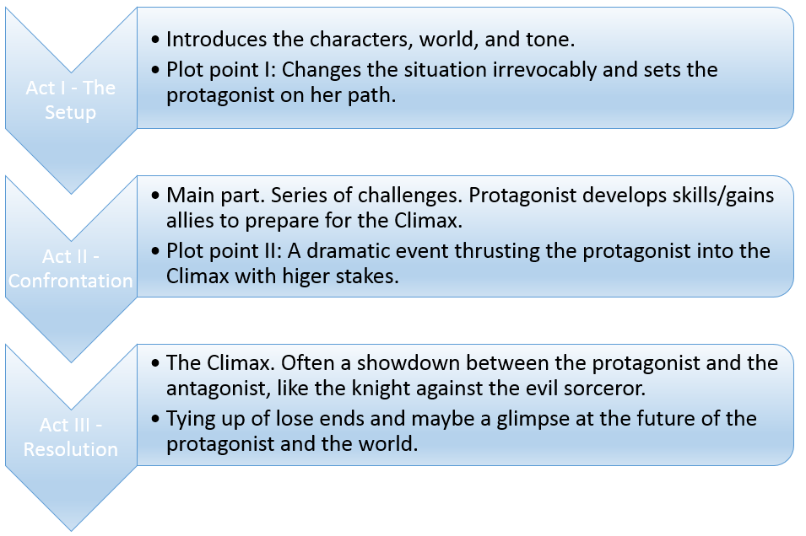
Three-act structures in board games
OK, now that we know what a three-act structure is, let’s try to see whether we can find the structure in solitaire board games.
I’ve spend a lot of time playing games from the States of Siege series the past few months, so I’ll start out by considering a couple of them.
In We Must Tell the Emperor you play the Japanese in Word War II. The game contains a set of event cards that controls the narrative of the game and it’s divided into three decks. You play through these three decks one by one, and each deck always starts with the same card (and deck one always ends with a specific card). This neatly separates the game into three acts.
The first deck starts out with Pearl Harbor, whose mere name will most likely invoke powerful mental imagery in the player, and thus is not only a good place to start from a historic point of view, but also because it’s powerful. It also serves as the event that awakens the main antagonist of the game: The Americans. At this point, the Japanese, who you as the player control, are on top. So we start while all is well, though we see the enemy stirring, which foreshadows the attack that’s about to arise and make the happy days come to an end.
Then WHAM! The Battle of Midway smacks you into a harsher reality where the enemy shows its power and presents a clear threat to you. The world of the Japanese military is irrevocably changed. This is the Plot Point I, which signals the transition to Act II. What initially looked like Japanese supremacy turns out to be a fight for survival and the Fundamental Question becomes: Will the Japanese survive?
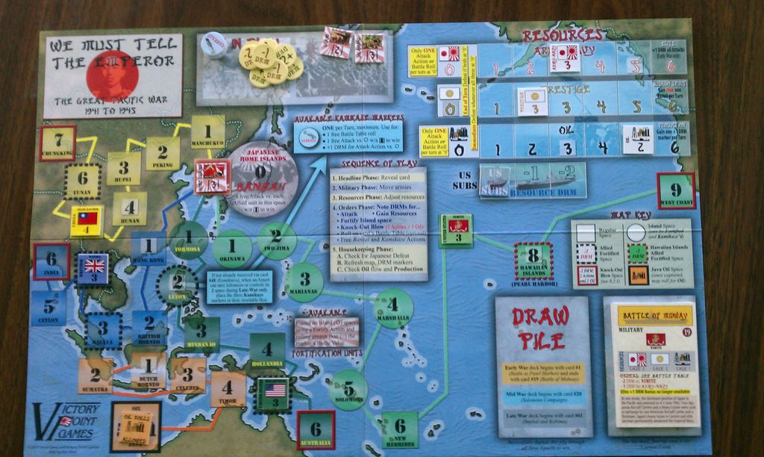
Image Credit:
Rick Thompson
. We Must Tell the Emperor. Plot Point I, The Battle of Midway, ends Act I.
You spend the second act facing challenge after challenge fighting to hang on to what you’ve got, leading up to the Plot Point II, which doesn’t really happen in the game, because while the game has followed the classical three-act structure well so far the end deviates. It’s one drawn out struggle for survival while gradually losing ground instead of a single climax. This, however is not meant as a critique of We Must Tell the Emperor, since designer Steve Carey quite reasonably chose to follow history, which didn’t have one final showdown where the Japanese overcame their enemies, and Steve’s goal was clearly to convey history to us.
Furthermore it’s not only that history dictated a drawn out ending instead of an epic showdown, it’s actually an almost inescapable feature of the States of Siege engine that we’ll get hanging on by the nails survival stories, not showdowns. Of the 11 States of Siege games I’ve tried I’d say that only one of them has changed this feature: Mound Builders.
States of Showdown
Mound Builders does this by adding in Spanish Conquistadors who attack your Native American empire, during the final part of the game. They attack in two waves, and the attacks are foreshadow by an event card that places them on the map and serves as Plot Point II. The attacks of the Spanish follows somewhat different rules than those of your other enemies: They’re stronger, and they will continue to attack until they’re stopped. If you stop both of their attack waves you immediately win the game. These features make them stand out in your mind and marks their attack as something special and more dangerous, and create a nice Climax for the game.
So in this way Mound Builders adds a “true” Act III to the States of Siege formula, and I think that from a narrative perspective it’s a very good addition.
As mentioned Mound Builders has special rules for the Spanish, which helps make Act III feel climatic. The game goes much further than this though, and in general changes rules from one act to another. One example of this is Diplomacy.
You’ll spend Act I expanding your empire through diplomacy. In Act II this option disappears, but you can still use diplomacy to negotiate temporary peace. Finally in Act III there’s no such thing as diplomacy. These rule changes help make each act feel distinct and supports the feel of each of them, and reinforces the three-act structure.
Instead of having the rule changes for the Acts in the rulebook another option is going the way of Lord of the Rings LCG, which has a special mini deck of cards for each scenario. You turn over one of these cards per Act and it contains some flavor text and very often a special rule that’s active during this Act. This works out as a simple and effective way of enforcing a set of distinct acts on the narrative of the game
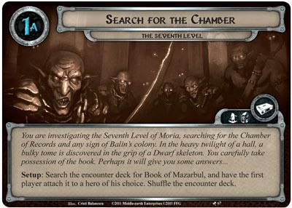
Image credit
Kris Vanhoyland
. A scenario card in Lord of the Rings LCG, which defines a scene in the game.
Skipping Act I
On the surface the game Friday seems to have a four act structure, because it has three “challenge” phases plus a final showdown with two pirate crews. I’d argue though that in reality the first three phases all belong to the same Act, since the only difference between them is that the difficulty of the challenges are cranked up from one phase to the next.
So if we accept this idea we get an Act II that consists of the player overcoming challenge after challenge and apart from overcoming challenges the players goal is improving his deck, which represents his skills and thus we have an explicit implementation of the Character Arc. Thus Friday’s structure is a good fit for Act II and Act III of the three-act structure, though it lacks a Plot Point II.
Now if I think that this game has only two acts, why do I then talk about it in a post about the three-act structure? That’s because I actually don’t think that Friday is a two acter – I actually think that it’s a three-acter with Act I being the implicit story that went before it – i.e. Robinson Crusoe going on a voyage and Plot Point I being the ship wreck and making it to the island.
In stories Act I is often quiet with little danger, which is fine in a story that you read once, but in a game that you’ll play over and over it could get boring, and thus it makes sense to skip this Act. One way of avoiding the quietness of Act I leading to player boredom is to allow the player to build something during this act, because that appeals to a lot of people. This is the approach taken by Mound Builders, where you build up your empire during Act I.
So, there can be an advantage to skipping Act I in board games, but there’s also advantages of keeping it in – it makes the narrative of the three-act structure stronger because it makes the player more emotionally invested. While defending in Mound Builders I felt like defending my empire, not someone else’s empire (i.e. the game designer’s), because I had actually built the empire, and it has the added advantage that it replaces a longwinded setup with interesting gameplay.
It seems to me that the most common approach in board games is to be skipping Act I, though we could of course take the title of Act I, “The Setup”, literally and decide that setting up the game is Act I .
Boss Monsters
Both Mound Builders and Friday have their Climax implemented by an enemy that’s much stronger than any that has come before – i.e. a boss monster, and having a boss monster as the Climax is actually quite common in solitaire games. Goblins vs. Zombies has it, Witch of Salem has it, and Darkest Night has it.
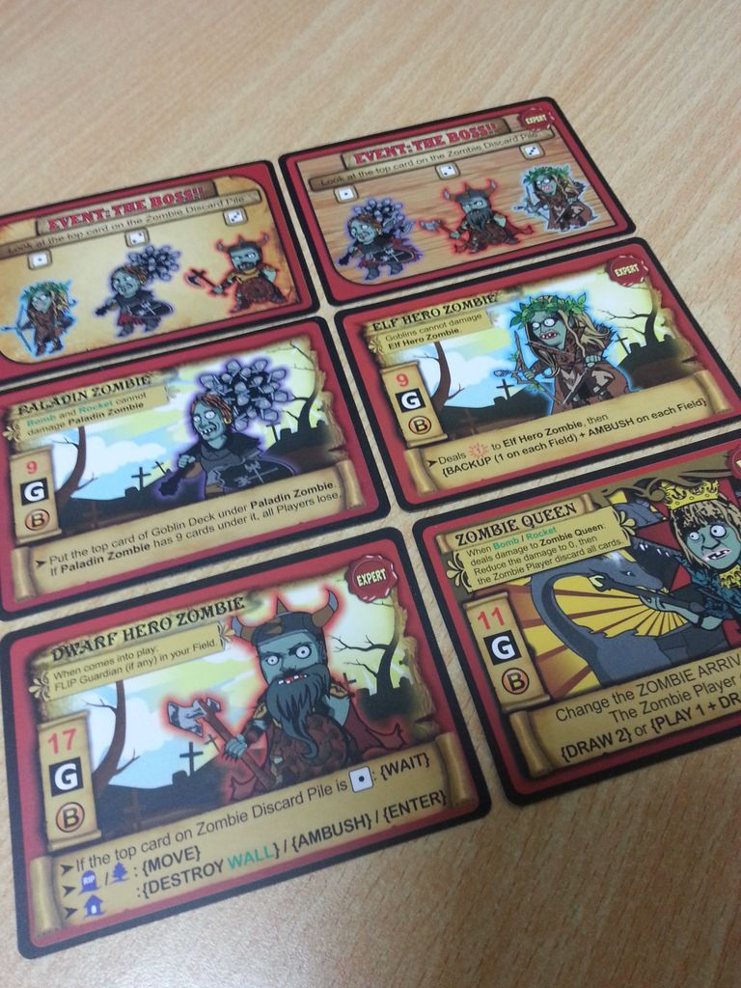
Image credit:
Kris Ardianto
. Boss Monsters in Goblins vs. Zombies.
There’s a reason that the boss monster mechanic has been so widespread, particularly in videogames, and that reason is quite simply that it works. It makes the end feel extra dangerous and special – it feels like a climax and thus it hooks into the same psychological mechanics that the three-act structure does.
Plot Points
As mentioned above We Must Tell the Emperor has a Plot Point I and Mound Builders has both a Plot Point I and II. In both these games the Plot Points are very effective in conveying the narrative of the game and making it exciting, but despite this it seems to me that fairly few games has explicit Plot Points, which I think is a pity.
The game, Hostage Negotiator is very explicit about having a Plot Point II. The last event card in the game is taken from a special deck of cards called “pivotal events”, which generally have more extreme effects than the other event cards.
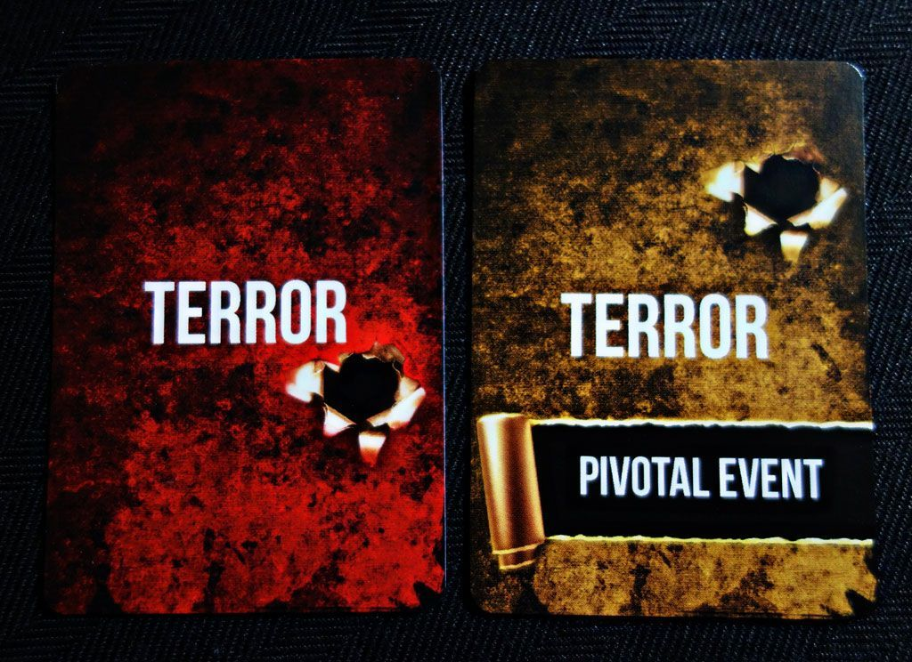
Image credit:
Tracy Baker
. Hostage Negotiator use special event cards called “pivotal events” to act as Plot Point II in the game’s narrative.
When a game of Hostage Negotiator goes by the book (it often, but not always, does this), then it’s a poster child for how well the Act II -> Plot Point II -> Act III part of the three-act structure works to create exciting narratives. You spend Act II getting ready for the showdown, while the stakes rise. Then the pivotal event sets the scene for the Climax in Act III, which is a single turn of double length, where you fire off everything that you’ve built up during the main part of the game. This double length and using everything you’ve got, while the outcome of game hangs in the balance works very well to mark the last turn as a climax.
Ask yourself…
In my opinion many game designers hasn’t realized how powerful the three-act structure can be, and thus we get games that only has Act II, e.g. Astra Titanus, Dungeon Roll, and Castle Panic. The last of these even has boss monsters, but they can show up at any time during the game, and it most often ends by petering out a turn or two after the draw pile runs out, instead of ending with a bang.
So when designing a game try to ask yourself, can I add
an Act I that makes the player more invested in the characters and game world?
a Climax that ends the game? Perhaps with the normal rules of the game tweaked a bit?
Plot Points I and II?
You may not be able to do these things in your game, but if you can you’ll get an easy way to hook into a structure that has over millennia has been shown to hook into the human psyche and create narratives that resonate with us.

What is Your Board Game’s Story?
Posted on December 2, 2021 by Duke Of BAzlandia
Sam “King of the Hilltop”
When defining a game design or a board game, it is often more then just the theme that defines the game. It’s the actions, the mechanics, and the interactions between players along with the theme that define what a game is. For me, I sum that up as the “story” of the game.
Meriam-Webster defines story as – an account of incidents or events. There are some other ways to define it but I like this description. It is very broad and applicable to entertainment. These incidents and events allow a board game to be a story and it manifests in your life all the time when it comes to board games.

The Description
When you are introducing a board game to someone, how do you do it? You may start off with, “So, this is a game about being a corporation and you are Terraforming Mars!” That is a good beginning. It establishes the kind of story/experience that is going to happen. However, I find that it rarely ends there. If there is an interest, you have to go deeper, “Well, it’s a game that we can play for the 4 of us. It will take 2 hours-ish. It’s a game where you try and get points by accomplishing goals and building up your corporation’s ability to plant trees, build cities, research science and technologies, and develop infratructure for Mars.”
You have established their interest and now you have a general idea of different things you can choose to do in the game. Does that sound interesting enough to play? For me, it’s not only the theme that gets me to buy a game, but how the gameplay manifests and matters to the game, or in other words, how do the actions we make relate to the story?
This experience is what drives me to love board games. The choices you make, the puzzles you have to figure out, and how that all plays together with the theme to create a unique play experience, or story.

Who, What, Where, Why, How – Creating the Story
I think a good way to break down a board game is to break it down like you would a story. Who, What, Where, Why, and How.
Who – Who is going to play? How many people? This is another factor that we sometimes overlook as a designer because we become so used to certain ideas. If I were to tell you to design a stereotypical Euro game, how many players would you say it would be? 2-4? 1-5? How often have you seen one able to comfortably play with 6 players? Why is that? The number of players weighs heavily on the design process as typically the more complicated a game becomes, the less players it will be able to play. Not always true but that will then affect the decision of how much should a player be doing on their turn or during the round.
What – This is the theme of the game, what is taking place. This one can be difficult or easy depending on how you approach game design but this is the central idea that ties everything together. Terraforming Mars is a good example of this. All of the different choices in the game lead back to the idea of terraforming a planet called Mars. Whether it’s improving the oxygen level, blowing up meteors, or seeking fame by accomplishing various goals. All actions lead to the theme or the “what” in this case.
Where – The medium that you choose for the game matters. Will it be a board game played in person? Will it be accessible to be played online via audio or video calls? Will it be available online? Is it a video game? We tend to make these choices fairly quickly and many times without much thought but I have seen a lot more discussion about this subject since the pandemic. The medium by which the game is played needs to be considered carefully. Some games can strongly benefit from the ability to play in a variety of ways. One example I noticed is quite a few roll and write style games being played online without the use of Tabletop Simulator or any software mediums other than Skype.
This consideration will even go as far to affect how people feel about a game. A recent discussion happened where someone mentioned how much they missed the physicality of board games since they played almost exclusively online for a year. When they went back to handling physical coins and talking in person, the games they grew bored of over the year became much more enjoyable to them. The way we tell a message as a board game designer is worth the effort. Please don’t forget how you are going to tell the story.
Why – This is the reason to win and the win condition. In Terraforming Mars the player becomes the most influential force behind the terraforming of the planet. You do that by having the most Victory Points. I wish they would have renamed them to Influence Points as it fits the theme and story better but Victory Points is not confusing and easy to understand. Most people know what Victory Points are.
In some games, it is to be the last one standing. In others, the most points. In others, have the least number of points. This is all a reflection of how the game is supposed to be played. In a game with the last one standing, that is likely a very competitive game and you know it from the start. In a game where you earn victory points, you are likely building something or doing actions to provide points, I would guess a form of engine building in one of its many forms.
How – The mechanics of the game. This is literally how the game is played and depending on how a game is designed, it will effect the mood and feel of the game. For example, a very popular game mechanic is worker placement. You place a worker down in a location and get the benefits of that location. However, many games of that style also brings in a denial component. If I place a worker there, other players can’t play there or they have to pay extra in order to do get the same benefit. This provides a bit of anxiety and attention from other players as you seek the best locations for your workers. This inherently feels different from Yahtzee style dice mechanics, where you have a set of dice and you roll them and may have additional re-rolls in order to try and accomplish an objective, earn points, make certain patterns. There is anxiety but it has more to do with probability and less pointed at the other players.

The Full Story
I woud honestly challenge any designer working on a game to fill out these 5 questions. It will be up to you how it all glues together in the long run but this can be a useful tool to use if you feel like a design is not working together. The different aspects of the game feel clunky and unrelated. You can even drill this down to every aspect of the game. Take a particular mechanic you are using and fill out the 5 questions related to that mechanic. Who is using the mechanic? What is the mechanic thematically? Where is the mechanic taking place? Why use this mechanic and why does it help a player win? How is the mechanic being used physically?
By examining our game designs from the perspective of a story, it can show us the game’s logic and how that is then interpreted by a board game.
Ed “Duke of BAzlandia”

I Enjoy The Wheel of Time Adaptation
There, I have said it. I mean it. If you were to ask my brother, I have just committed a heresy punishable by death. But, alas, I have to admit I enjoy the show. I enjoy the story. To give you some background, I started reading The Wheel of Time back in the mid 90’s. I was in middle school and I enjoyed reading those big thick fantasy novels. I hate to admit but there were even times I got grounded and not from TV or video games but from reading. I know, nerd.
The story contained in The Wheel of Time is something I have enjoyed through the decades. I have gone back and read the entire series twice and have read several individual books in the series multiple times more than that. When I heard there was going to be a television adaptation, I was excited, but also nervous. There being the “Winter Dragon” adaptation of the first book’s prologue…. yeah, just pretend that doesn’t exist. You will be better off never witnessing that.
I was also excited since adaptations of books and other media into television and movies have become better. Knowing all of this I set myself up to not being disappointed on release date by staying abreast of all the news and rumors. One of the ways I set myself up for success was telling myself that as long as they set the world up correctly and didn’t break or completely alter the integrity of the world, I could enjoy the show.
When I talk about the integrity of the world, I refer to the basis of how things work and what is feasible for character, etc. What works in a book doesn’t necessarily work on screen. Examples of this are Inner dialogues, vast world descriptions, long dialogues on how a particular culture operates, or even the sheer mass of characters with small parts that show up in Book 1 and then not again until Book 7.
In the world of The Wheel of Time there are things called portal stones. Basically, magic users can use these to visit and see alternate realities of their world. I view the television show as one of these alternate realities. This allows for rearranging of events, aging of characters, etc. This doesn’t mean I agree with all of the decisions made for the adaptation but it does mean I can understand it and still enjoy the show.
What does this all have to do with board games? Board games are stories. They tell some sort of story based on the theme of the game. Whether this is players crawling through dungeons (Hero Quest), Cult members killing each other (Cult of the Deep), European gem mining (Splendor), two armies at war (Chess or Go) or even the colonization of Mars (Terraforming Mars). Each game tells a story and each time a game is played it tells a variant of the same story. Events happen in different ways, times, and with different characters. But the game world still exists and still maintains its integrity, or in this particular case, game rules. A good game tells a good story as the game events unfold. There are close calls, tense moments, and players watching as their strategy unfolds.
Replayability in a game in many ways is like adapting a book to a television story. It can’t be the same story but it needs to maintain that same essence or integrity. When an adaptation goes bad it is usually due to breaking the integrity of the story. In games, replayability needs to add or reorder the game so it isn’t the same game. It needs to tell the same story but in a different way. It needs to continue to engage players, bring back the same ups and downs as the first couple of plays but in a way that is not the same or monotonous. If a game revolves around the same strategy and that is the only option, it loses something of itself through multiple play throughs. It isn’t going to be the game that comes out every game night. It will be the game that comes out a few times and then goes to the shelf to collect dust.
I think it is important to keep in mind when designing games that really you are designing a world where players will go to create a story, using the rules that you have laid out.

